

Mawlana Bhashani Science and Technology University
Santosh, Tangail-1902.

Lab Report

Department of Information and Communication Technology

Report No: 03

Report Name: TCP and router queues.

Course Title: Wireless and Mobile Communication Lab

Course Code: ICT-4202

Submitted By | Submitted To
Name: S. M Atiqur Rahman  ID: IT-16052  Session: 2015-16  4th Year 2nd Semester  Dept. of Information & Communication Technology,  MBSTU. | Nazrul Islam  Assistant Professor  Dept. of Information & Communication Technology,  MBSTU.

Submission Date: 11-09-2020

Objective:

For TCP and router queues, we have to create a simple topology with two client node1, node 2 on the left side and node3 and node4 in the right side. We have to add drop tail queues of size QueueSize5 and QueueSize6 to Node5 and Node5 and Node6. Install a TCP socket instance on Node1 that will connect to Node3.

We have to Install a TCP socket instance on Node2 that will connect to Node3 and also Install a TCP socket instance on Node2 that will connect to Node4. Measure packet loss and cwnd size, and plot graphs throughput/time, cwnd/time and packet loss/time for each of the flows.

Source Code:

// Network topology
//
// 192.168.1.0 192.168.2.0
// n1 ------------------------------------ n2 ----------------------------------- n3
// point-to-point (access link) point-to-point (bottleneck link)
// 100 Mbps, 0.1 ms bandwidth [10 Mbps], delay [5 ms]
// qdiscs PfifoFast with capacity qdiscs queueDiscType in {PfifoFast, ARED, CoDel, FqCoDel, PIE} [PfifoFast]
// of 1000 packets with capacity of queueDiscSize packets [1000]
// netdevices queues with size of 100 packets netdevices queues with size of netdevicesQueueSize packets [100]
// without BQL bql BQL [false]
// *** fixed configuration ***
//
// Two TCP flows are generated: one from n1 to n3 and the other from n3 to n1.
// Additionally, n1 pings n3, so that the RTT can be measured.
//
// The output will consist of a number of ping Rtt such as:
//
// /NodeList/0/ApplicationList/2/$ns3::V4Ping/Rtt=111 ms
// /NodeList/0/ApplicationList/2/$ns3::V4Ping/Rtt=111 ms
// /NodeList/0/ApplicationList/2/$ns3::V4Ping/Rtt=110 ms
// /NodeList/0/ApplicationList/2/$ns3::V4Ping/Rtt=111 ms
// /NodeList/0/ApplicationList/2/$ns3::V4Ping/Rtt=111 ms
// /NodeList/0/ApplicationList/2/$ns3::V4Ping/Rtt=112 ms
// /NodeList/0/ApplicationList/2/$ns3::V4Ping/Rtt=111 ms
//
// The files output will consist of a trace file with bytes in queue and of a trace file for limits
// (when BQL is enabled) both for bottleneck NetDevice on n2, two files with upload and download
// goodput for flows configuration and a file with flow monitor stats.
//
// If you use an AQM as queue disc on the bottleneck netdevices, you can observe that the ping Rtt
// decrease. A further decrease can be observed when you enable BQL.

#include "ns3/core-module.h"
#include "ns3/network-module.h"
#include "ns3/internet-module.h"
#include "ns3/point-to-point-module.h"
#include "ns3/applications-module.h"
#include "ns3/internet-apps-module.h"
#include "ns3/traffic-control-module.h"
#include "ns3/flow-monitor-module.h"

using namespace ns3;

NS_LOG_COMPONENT_DEFINE ("BenchmarkQueueDiscs");

void
LimitsTrace (Ptr<OutputStreamWrapper> stream, uint32_t oldVal, uint32_t newVal)
{
*stream->GetStream () << Simulator::Now ().GetSeconds () << " " << newVal << std::endl;
}

void
BytesInQueueTrace (Ptr<OutputStreamWrapper> stream, uint32_t oldVal, uint32_t newVal)
{
*stream->GetStream () << Simulator::Now ().GetSeconds () << " " << newVal << std::endl;
}

static void
GoodputSampling (std::string fileName, ApplicationContainer app, Ptr<OutputStreamWrapper> stream, float period)
{
Simulator::Schedule (Seconds (period), &GoodputSampling, fileName, app, stream, period);
double goodput;
uint64_t totalPackets = DynamicCast<PacketSink> (app.Get (0))->GetTotalRx ();
goodput = totalPackets * 8 / (Simulator::Now ().GetSeconds () * 1024); // Kbit/s
*stream->GetStream () << Simulator::Now ().GetSeconds () << " " << goodput << std::endl;
}

static void PingRtt (std::string context, Time rtt)
{
std::cout << context << "=" << rtt.GetMilliSeconds () << " ms" << std::endl;
}

int main (int argc, char *argv[])
{
std::string bandwidth = "10Mbps";
std::string delay = "5ms";
std::string queueDiscType = "PfifoFast";
uint32_t queueDiscSize = 1000;
uint32_t netdevicesQueueSize = 50;
bool bql = false;

std::string flowsDatarate = "20Mbps";
uint32_t flowsPacketsSize = 1000;

float startTime = 0.1f; // in s
float simDuration = 60;
float samplingPeriod = 1;

CommandLine cmd;
cmd.AddValue ("bandwidth", "Bottleneck bandwidth", bandwidth);
cmd.AddValue ("delay", "Bottleneck delay", delay);
cmd.AddValue ("queueDiscType", "Bottleneck queue disc type in {PfifoFast, ARED, CoDel, FqCoDel, PIE, prio}", queueDiscType);
cmd.AddValue ("queueDiscSize", "Bottleneck queue disc size in packets", queueDiscSize);
cmd.AddValue ("netdevicesQueueSize", "Bottleneck netdevices queue size in packets", netdevicesQueueSize);
cmd.AddValue ("bql", "Enable byte queue limits on bottleneck netdevices", bql);
cmd.AddValue ("flowsDatarate", "Upload and download flows datarate", flowsDatarate);
cmd.AddValue ("flowsPacketsSize", "Upload and download flows packets sizes", flowsPacketsSize);
cmd.AddValue ("startTime", "Simulation start time", startTime);
cmd.AddValue ("simDuration", "Simulation duration in seconds", simDuration);
cmd.AddValue ("samplingPeriod", "Goodput sampling period in seconds", samplingPeriod);
cmd.Parse (argc, argv);

float stopTime = startTime + simDuration;

// Create nodes
NodeContainer n1, n2, n3;
n1.Create (1);
n2.Create (1);
n3.Create (1);

// Create and configure access link and bottleneck link
PointToPointHelper accessLink;
accessLink.SetDeviceAttribute ("DataRate", StringValue ("100Mbps"));
accessLink.SetChannelAttribute ("Delay", StringValue ("0.1ms"));

PointToPointHelper bottleneckLink;
bottleneckLink.SetDeviceAttribute ("DataRate", StringValue (bandwidth));
bottleneckLink.SetChannelAttribute ("Delay", StringValue (delay));

InternetStackHelper stack;
stack.InstallAll ();

// Access link traffic control configuration
TrafficControlHelper tchPfifoFastAccess;
tchPfifoFastAccess.SetRootQueueDisc ("ns3::PfifoFastQueueDisc", "MaxSize", StringValue ("1000p"));

// Bottleneck link traffic control configuration
TrafficControlHelper tchBottleneck;

if (queueDiscType.compare ("PfifoFast") == 0)
{
tchBottleneck.SetRootQueueDisc ("ns3::PfifoFastQueueDisc", "MaxSize",
QueueSizeValue (QueueSize (QueueSizeUnit::PACKETS, queueDiscSize)));
}
else if (queueDiscType.compare ("ARED") == 0)
{
tchBottleneck.SetRootQueueDisc ("ns3::RedQueueDisc");
Config::SetDefault ("ns3::RedQueueDisc::ARED", BooleanValue (true));
Config::SetDefault ("ns3::RedQueueDisc::MaxSize",
QueueSizeValue (QueueSize (QueueSizeUnit::PACKETS, queueDiscSize)));
}
else if (queueDiscType.compare ("CoDel") == 0)
{
tchBottleneck.SetRootQueueDisc ("ns3::CoDelQueueDisc");
Config::SetDefault ("ns3::CoDelQueueDisc::MaxSize",
QueueSizeValue (QueueSize (QueueSizeUnit::PACKETS, queueDiscSize)));
}
else if (queueDiscType.compare ("FqCoDel") == 0)
{
tchBottleneck.SetRootQueueDisc ("ns3::FqCoDelQueueDisc");
Config::SetDefault ("ns3::FqCoDelQueueDisc::MaxSize",
QueueSizeValue (QueueSize (QueueSizeUnit::PACKETS, queueDiscSize)));
}
else if (queueDiscType.compare ("PIE") == 0)
{
tchBottleneck.SetRootQueueDisc ("ns3::PieQueueDisc");
Config::SetDefault ("ns3::PieQueueDisc::MaxSize",
QueueSizeValue (QueueSize (QueueSizeUnit::PACKETS, queueDiscSize)));
}
else if (queueDiscType.compare ("prio") == 0)
{
uint16_t handle = tchBottleneck.SetRootQueueDisc ("ns3::PrioQueueDisc", "Priomap",
StringValue ("0 1 0 1 0 1 0 1 0 1 0 1 0 1 0 1"));
TrafficControlHelper::ClassIdList cid = tchBottleneck.AddQueueDiscClasses (handle, 2, "ns3::QueueDiscClass");
tchBottleneck.AddChildQueueDisc (handle, cid[0], "ns3::FifoQueueDisc");
tchBottleneck.AddChildQueueDisc (handle, cid[1], "ns3::RedQueueDisc");
}
else
{
NS_ABORT_MSG ("--queueDiscType not valid");
}

if (bql)
{
tchBottleneck.SetQueueLimits ("ns3::DynamicQueueLimits");
}

Config::SetDefault ("ns3::QueueBase::MaxSize", StringValue ("100p"));

NetDeviceContainer devicesAccessLink = accessLink.Install (n1.Get (0), n2.Get (0));
tchPfifoFastAccess.Install (devicesAccessLink);
Ipv4AddressHelper address;
address.SetBase ("192.168.0.0", "255.255.255.0");
address.NewNetwork ();
Ipv4InterfaceContainer interfacesAccess = address.Assign (devicesAccessLink);

Config::SetDefault ("ns3::QueueBase::MaxSize", StringValue (std::to_string (netdevicesQueueSize) + "p"));

NetDeviceContainer devicesBottleneckLink = bottleneckLink.Install (n2.Get (0), n3.Get (0));
QueueDiscContainer qdiscs;
qdiscs = tchBottleneck.Install (devicesBottleneckLink);

address.NewNetwork ();
Ipv4InterfaceContainer interfacesBottleneck = address.Assign (devicesBottleneckLink);

Ptr<NetDeviceQueueInterface> interface = devicesBottleneckLink.Get (0)->GetObject<NetDeviceQueueInterface> ();
Ptr<NetDeviceQueue> queueInterface = interface->GetTxQueue (0);
Ptr<DynamicQueueLimits> queueLimits = StaticCast<DynamicQueueLimits> (queueInterface->GetQueueLimits ());

AsciiTraceHelper ascii;
if (bql)
{
queueDiscType = queueDiscType + "-bql";
Ptr<OutputStreamWrapper> streamLimits = ascii.CreateFileStream (queueDiscType + "-limits.txt");
queueLimits->TraceConnectWithoutContext ("Limit",MakeBoundCallback (&LimitsTrace, streamLimits));
}
Ptr<Queue<Packet> > queue = StaticCast<PointToPointNetDevice> (devicesBottleneckLink.Get (0))->GetQueue ();
Ptr<OutputStreamWrapper> streamBytesInQueue = ascii.CreateFileStream (queueDiscType + "-bytesInQueue.txt");
queue->TraceConnectWithoutContext ("BytesInQueue",MakeBoundCallback (&BytesInQueueTrace, streamBytesInQueue));

Ipv4InterfaceContainer n1Interface;
n1Interface.Add (interfacesAccess.Get (0));

Ipv4InterfaceContainer n3Interface;
n3Interface.Add (interfacesBottleneck.Get (1));

Ipv4GlobalRoutingHelper::PopulateRoutingTables ();

Config::SetDefault ("ns3::TcpSocket::SegmentSize", UintegerValue (flowsPacketsSize));

// Flows configuration
// Bidirectional TCP streams with ping like flent tcp_bidirectional test.
uint16_t port = 7;
ApplicationContainer uploadApp, downloadApp, sourceApps;
// Configure and install upload flow
Address addUp (InetSocketAddress (Ipv4Address::GetAny (), port));
PacketSinkHelper sinkHelperUp ("ns3::TcpSocketFactory", addUp);
sinkHelperUp.SetAttribute ("Protocol", TypeIdValue (TcpSocketFactory::GetTypeId ()));
uploadApp.Add (sinkHelperUp.Install (n3));

InetSocketAddress socketAddressUp = InetSocketAddress (n3Interface.GetAddress (0), port);
OnOffHelper onOffHelperUp ("ns3::TcpSocketFactory", Address ());
onOffHelperUp.SetAttribute ("Remote", AddressValue (socketAddressUp));
onOffHelperUp.SetAttribute ("OnTime", StringValue ("ns3::ConstantRandomVariable[Constant=1]"));
onOffHelperUp.SetAttribute ("OffTime", StringValue ("ns3::ConstantRandomVariable[Constant=0]"));
onOffHelperUp.SetAttribute ("PacketSize", UintegerValue (flowsPacketsSize));
onOffHelperUp.SetAttribute ("DataRate", StringValue (flowsDatarate));
sourceApps.Add (onOffHelperUp.Install (n1));

port = 8;
// Configure and install download flow
Address addDown (InetSocketAddress (Ipv4Address::GetAny (), port));
PacketSinkHelper sinkHelperDown ("ns3::TcpSocketFactory", addDown);
sinkHelperDown.SetAttribute ("Protocol", TypeIdValue (TcpSocketFactory::GetTypeId ()));
downloadApp.Add (sinkHelperDown.Install (n1));

InetSocketAddress socketAddressDown = InetSocketAddress (n1Interface.GetAddress (0), port);
OnOffHelper onOffHelperDown ("ns3::TcpSocketFactory", Address ());
onOffHelperDown.SetAttribute ("Remote", AddressValue (socketAddressDown));
onOffHelperDown.SetAttribute ("OnTime", StringValue ("ns3::ConstantRandomVariable[Constant=1]"));
onOffHelperDown.SetAttribute ("OffTime", StringValue ("ns3::ConstantRandomVariable[Constant=0]"));
onOffHelperDown.SetAttribute ("PacketSize", UintegerValue (flowsPacketsSize));
onOffHelperDown.SetAttribute ("DataRate", StringValue (flowsDatarate));
sourceApps.Add (onOffHelperDown.Install (n3));

// Configure and install ping
V4PingHelper ping = V4PingHelper (n3Interface.GetAddress (0));
ping.Install (n1);

Config::Connect ("/NodeList/*/ApplicationList/*/$ns3::V4Ping/Rtt", MakeCallback (&PingRtt));

uploadApp.Start (Seconds (0));
uploadApp.Stop (Seconds (stopTime));
downloadApp.Start (Seconds (0));
downloadApp.Stop (Seconds (stopTime));

sourceApps.Start (Seconds (0 + 0.1));
sourceApps.Stop (Seconds (stopTime - 0.1));

Ptr<OutputStreamWrapper> uploadGoodputStream = ascii.CreateFileStream (queueDiscType + "-upGoodput.txt");
Simulator::Schedule (Seconds (samplingPeriod), &GoodputSampling, queueDiscType + "-upGoodput.txt", uploadApp,
uploadGoodputStream, samplingPeriod);
Ptr<OutputStreamWrapper> downloadGoodputStream = ascii.CreateFileStream (queueDiscType + "-downGoodput.txt");
Simulator::Schedule (Seconds (samplingPeriod), &GoodputSampling, queueDiscType + "-downGoodput.txt", downloadApp,
downloadGoodputStream, samplingPeriod);

// Flow monitor
Ptr<FlowMonitor> flowMonitor;
FlowMonitorHelper flowHelper;
flowMonitor = flowHelper.InstallAll();

Simulator::Stop (Seconds (stopTime));
Simulator::Run ();

flowMonitor->SerializeToXmlFile(queueDiscType + "-flowMonitor.xml", true, true);

Simulator::Destroy ();
return 0;
}

Output:

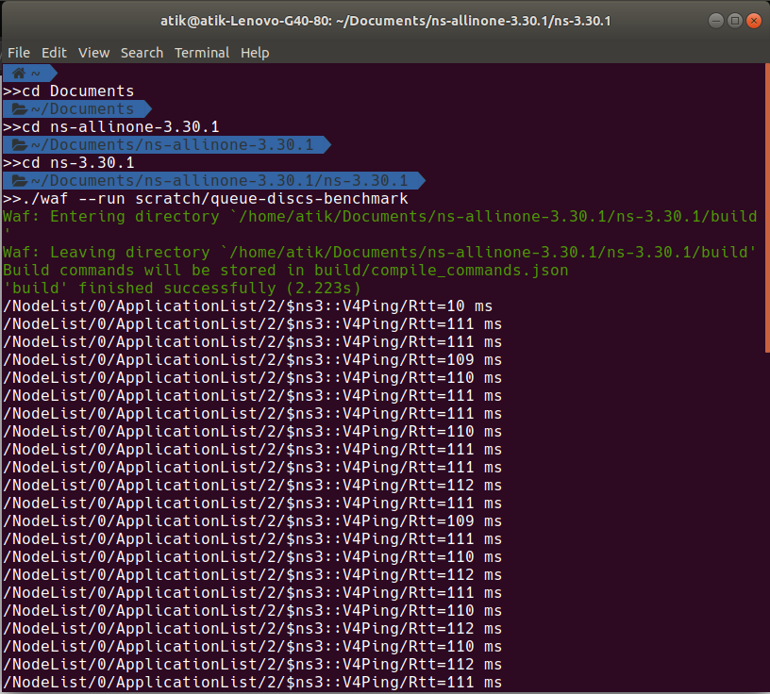

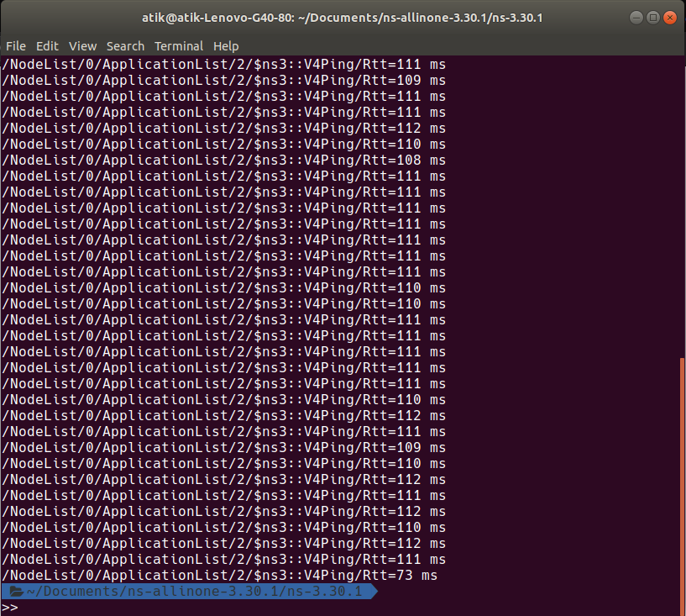

Conclusion:

The specific characteristics of TCP and Router queues include the manner in which they avoid routing loops, the manner in which they select preferred routes, using information. This has the added benefit of preventing issues with TCP and router queues loops. TCP and router is related to connecting the network packages simultaneously.

